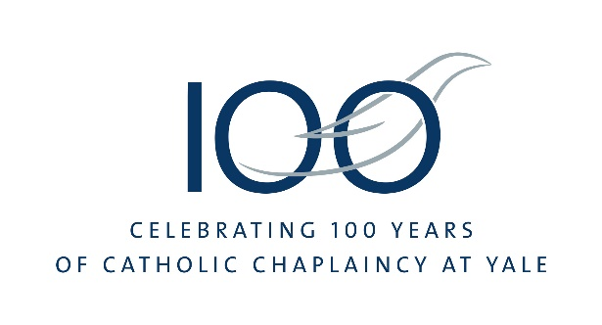
Father Robert Beloin
Chaplain 1994-2018

Affectionately known as “Fr. Bob,” he was born February 13, 1947 in Springfield, MA. Fr. Beloin always felt a strong call to the priesthood. His mother was a parish secretary and his father was a member of the Knights of Columbus. He became an altar boy in the fourth grade. Initially raised in Holyoke, MA, his family moved to Madison, CT, in 1962, where he graduated from Daniel Hand High School. He began his studies for the priesthood at St. Thomas Seminary in Bloomfield, CT, and later at Our Lady of Angels Seminary in Albany, NY. He received his B.A. and M.Div. from Our Lady of Angels and completed his M.A. in Moral and Religious Science at the University of Louvain in Belgium. Fr. Beloin was ordained to the priesthood for the Archdiocese of Hartford on August 25, 1973.
After his ordination, he served as Assistant Pastor at St. Ann Church in New Britain, CT, for five years and then returned to Europe as the Director of Pastoral Formation at the American College of Louvain. He served in this position for five years while he earned his Ph.D. in Religious Studies, magna cum laude, from the University of Louvain. In 1983, he became Associate Director of the Center for Human Development in Washington, D.C., and gave retreats for priests in the United States, Canada, Australia, England and Ireland. In 1991, he joined the Advisory Board for the National Alliance of Parishes Restructuring into Communities and spoke at conferences and gave workshops on restructuring throughout the United States and in eastern Australia. He was Co-Pastor at St. Barnabas Church in North Haven for ten years before being appointed the seventh Catholic Chaplain at STM in 1994.
For those who knew him, Fr. Beloin was the “heart and soul” of Catholic ministry at Yale University. He was also STM’s longest appointed Chaplain, with a tenure of just under twenty-five years. While Catholic Chaplain at Yale, he managed a capital campaign that culminated in the construction of the 30,000 sq. ft. Cesar Pelli designed Thomas E. Golden, Jr. Center as well as in the renovation of the Chapel and Residence.
Fr. Beloin was an inspiring force of pastoral service and intellectual vigor at STM: working in the Wednesday Soup Kitchen, directing programs for spiritual development and participating in inter­religious activities on campus. In addition to his duties as Catholic Chaplain, he was a Fellow of Trumbull College.
Fr. Beloin was also a formidable preacher, whose homilies helped many in the STM community deepen their faith. He was also known for a style of pastoral care that was equal parts gracious hospitality, thoughtful conversation, wry humor and detailed, deeply personalized care for all who sought his advice. In recognition of his many accomplishments on campus, the Association of Yale Alumni presented him with the Yale Medal, its highest award, in 2011.
Alongside his ministry at Yale, Fr. Beloin contributed to a wide range of pastoral activity in the Archdiocese of Hartford and on behalf of the wider Church. He died on September 23, 2018 of glioblastoma and is buried in Riggs Garden near STM’s first Chaplain, Fr. T. Lawrason Riggs ꞌ10.
Links
Yale Alumni Magazine. “A Chaplain’s Abundant Life.” https://yalealumnimagazine.org/articles/4788-robert-beloin

